**Name - Anirudh Reddy Betu**

**ID – 153023**

**Project**

**Herguan University**

1. Project with dependencies

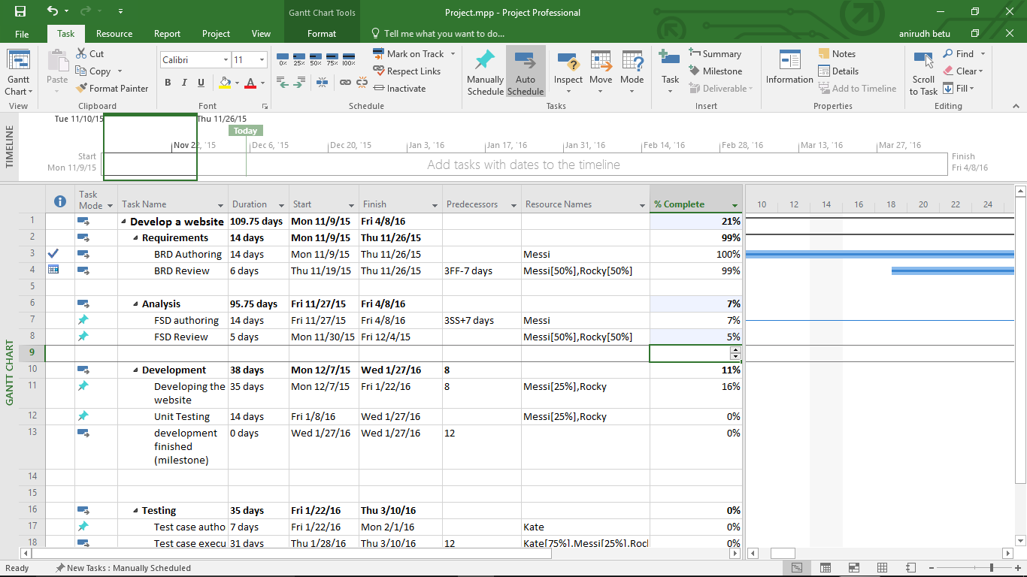

1. Gantt chart

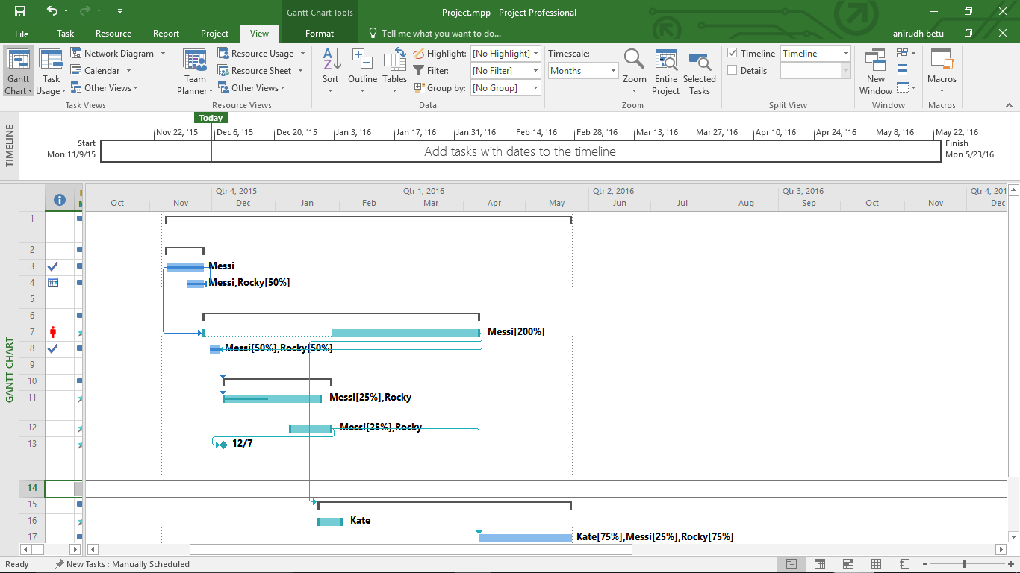

1. Critical Path - is the sequence of project network activities which add up to the longest overall duration, regardless if that longest duration has float or not. This determines the shortest time possible to complete the project.

Critacl path - > Format -> Critical task

Path colored in pink is critical path

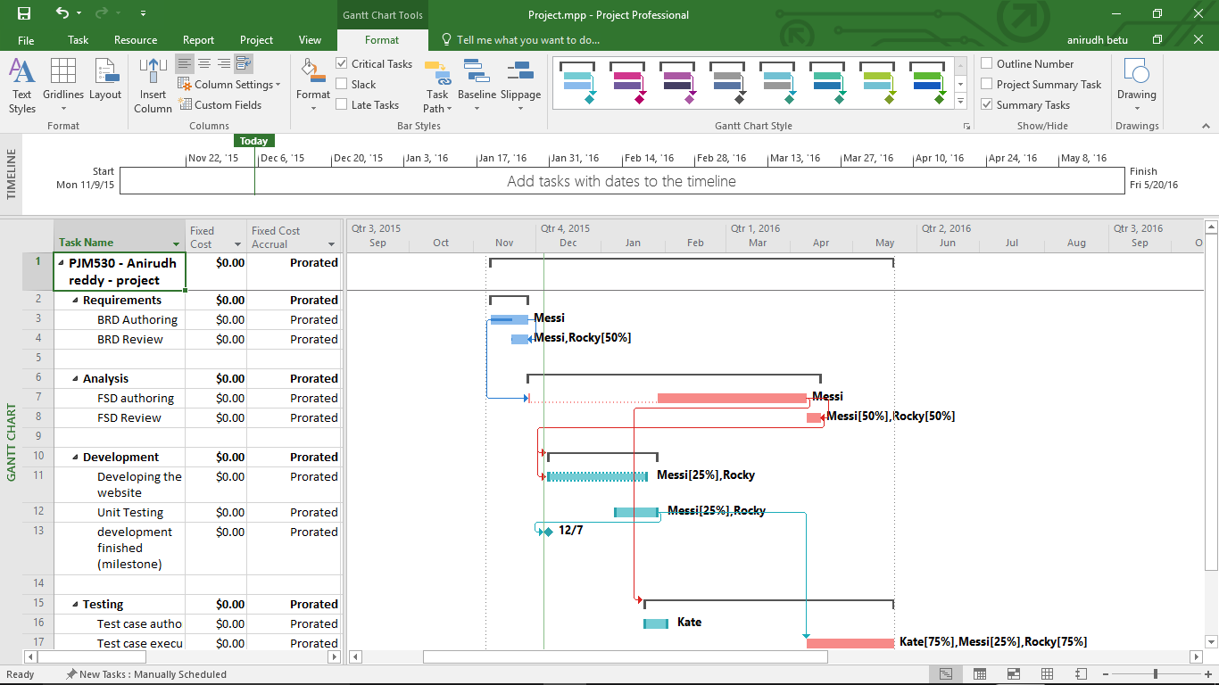

1. Recourses level – is leveling, Project does not change who is assigned to each task. Project levels only the work resources, generic resources, and committed resources. It does not level the material resources, cost resources, or proposed resources.

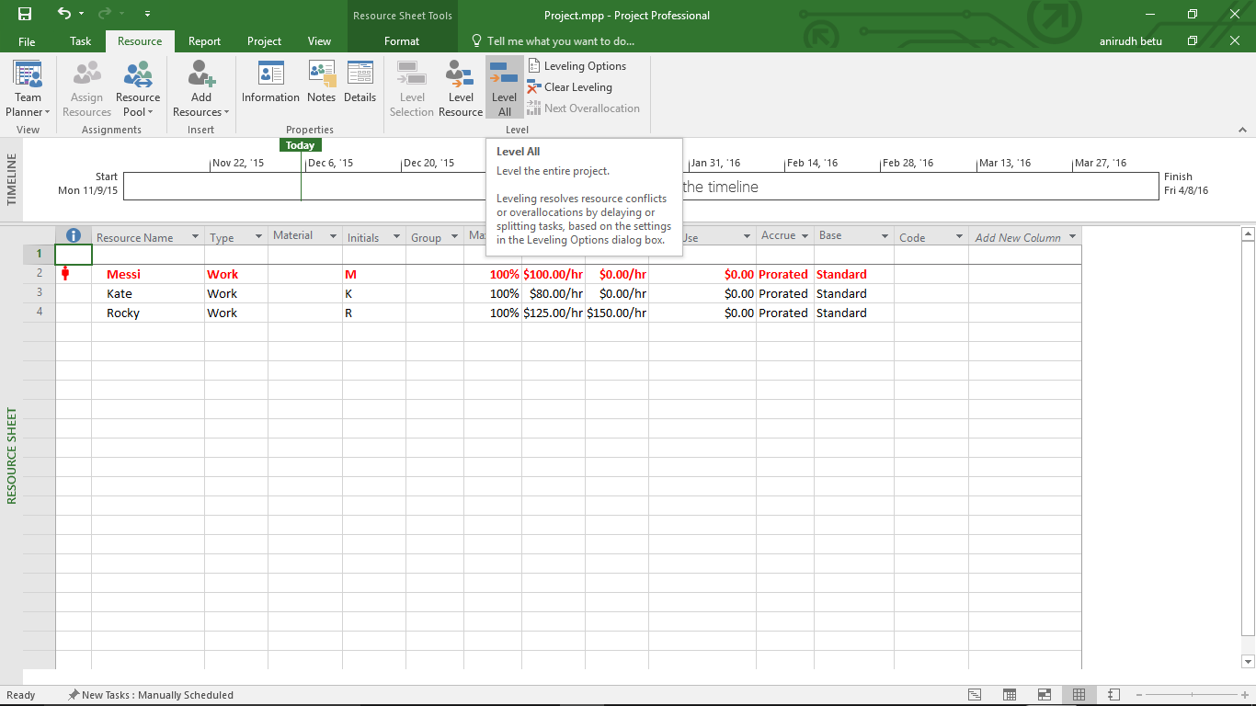

1. Setting project baseline –

A cost baseline is an approved time phased plan. Once a detailed budget is developed and approved, the project manager should publish this baseline and set it as a point of comparison for actual performance progress.

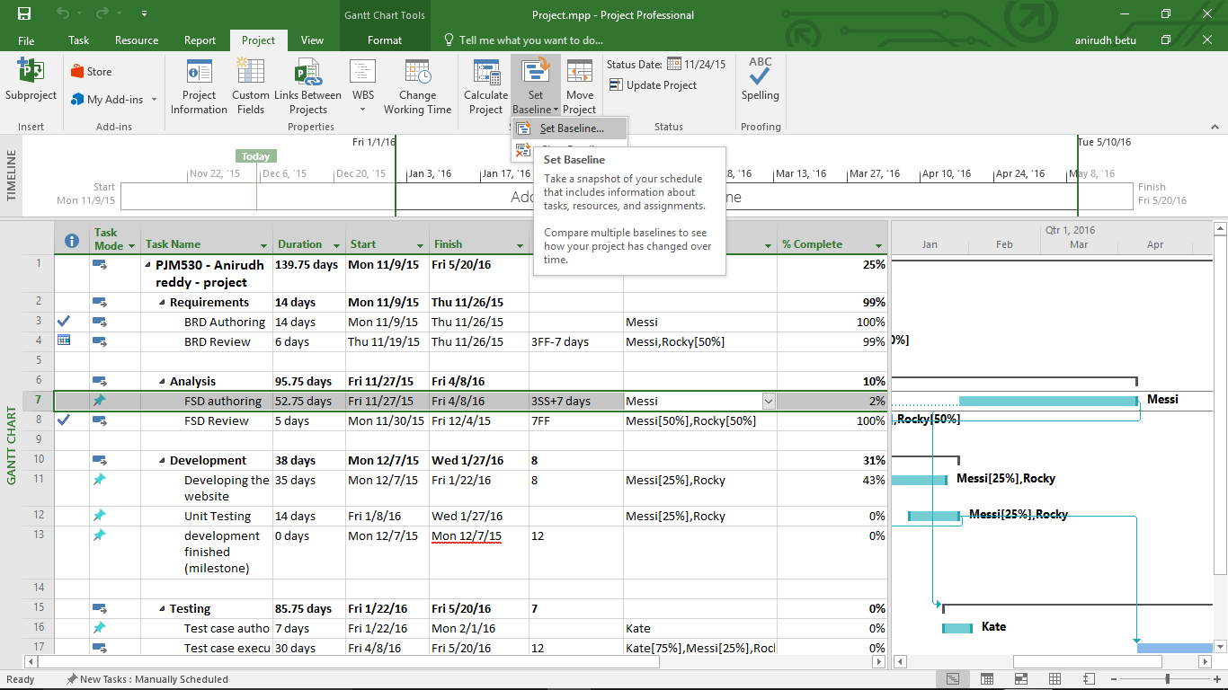

1. Earned value cost indicator

View -> Tables -> more tables -> earned value cost indicator

CPI = 1; value is 1 means that the project is doing exactly as planned against the budget.

CPI < 1; value of above 1 means that the project is doing well against the budget.

CPI > 1; value of less than 1 means that the project is not doing well against the budget.

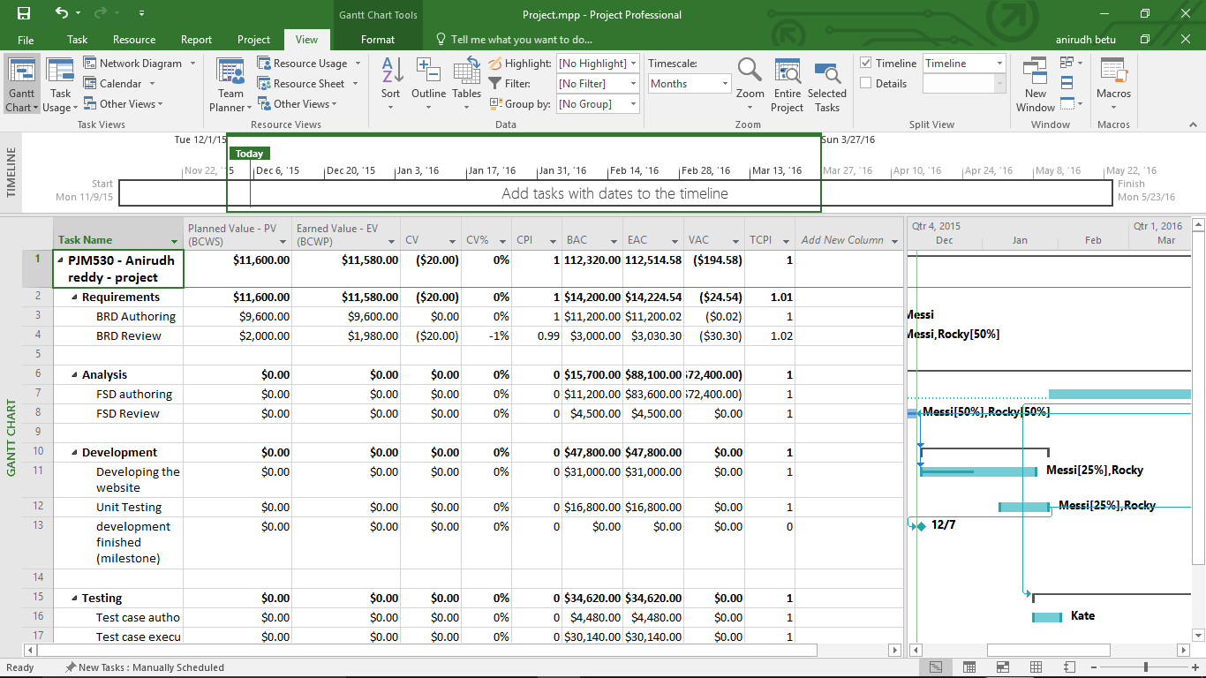

1. Earned value schedule indicator –

View -> Tables -> more tables -> earned value schedule indicator

SPI = 1; value is 1 means that the project is doing exactly as planned against the time.

SPI < 1; value of above 1 means that the project is doing well against the time.

SPI > 1; value of less than 1 means that the project is not doing well against the time.

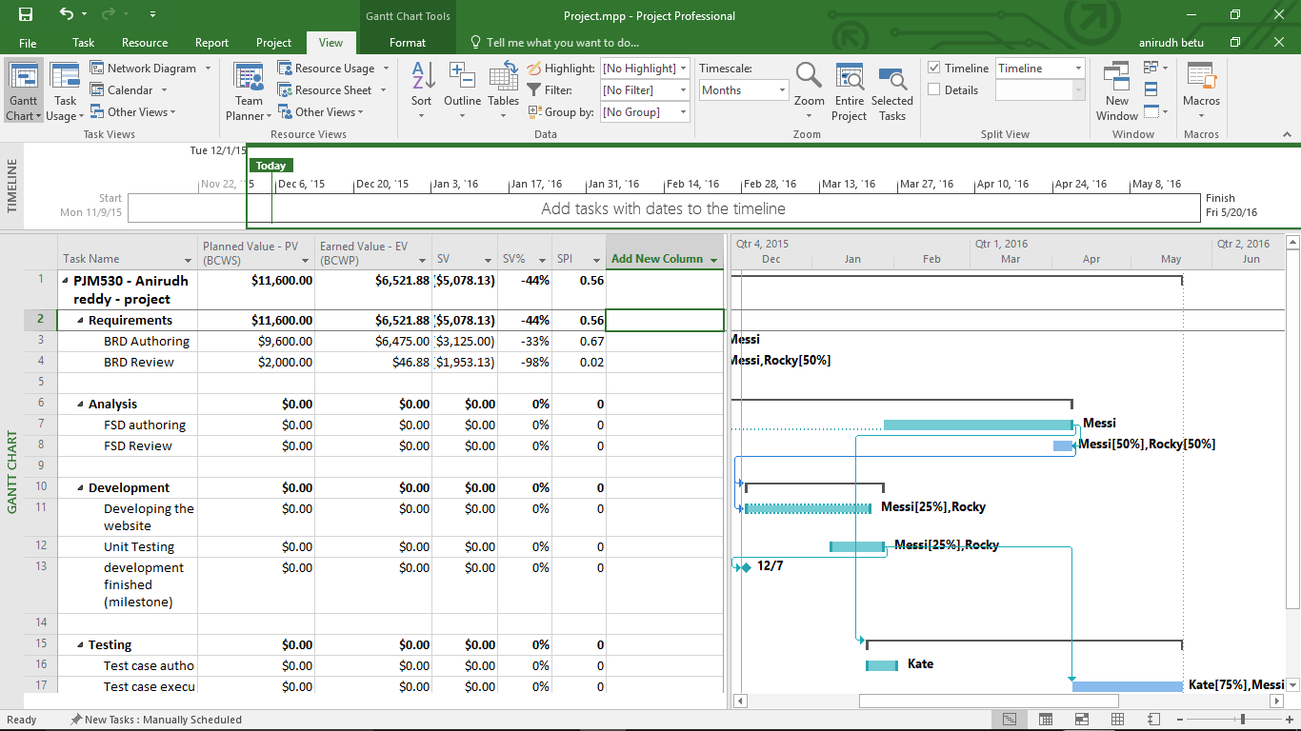

8) Slack in Gantt chart

Slack - Slack is the amount of time that a task can slip before it affects another task or the project's finish date. Use the Early Start, Early Finish, Late Start, Late Finish, Start Slack, and Finish Slack fields to analyze project schedule delays and find available slack in your schedule.

Here slack is 51.75 days

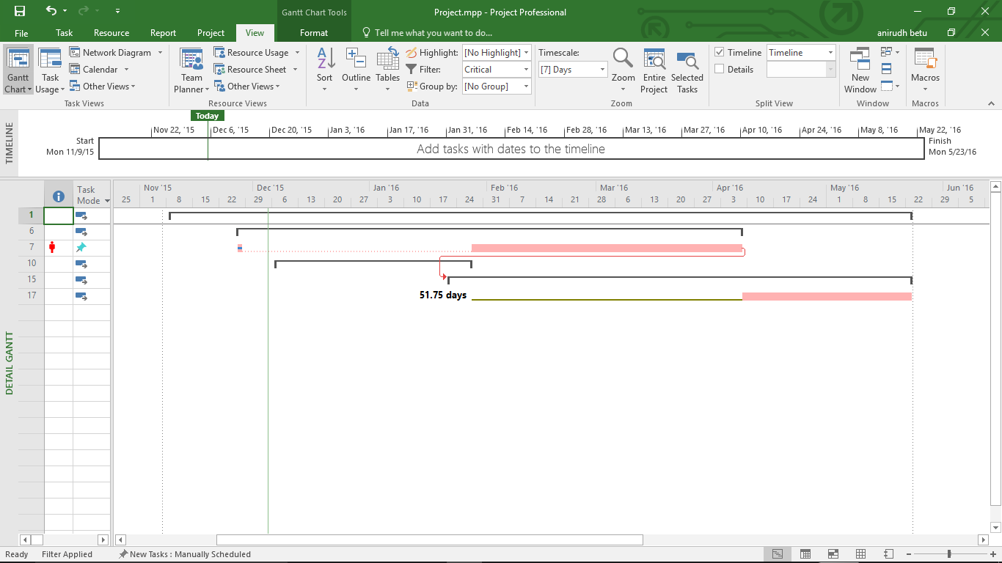

1. Mile stone – Mile stone is created by giving duration as 0.

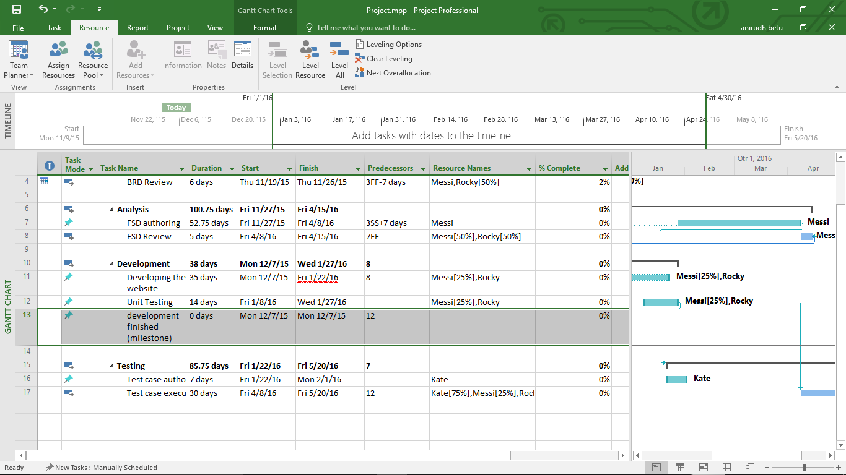

Milestone in Gantt chart

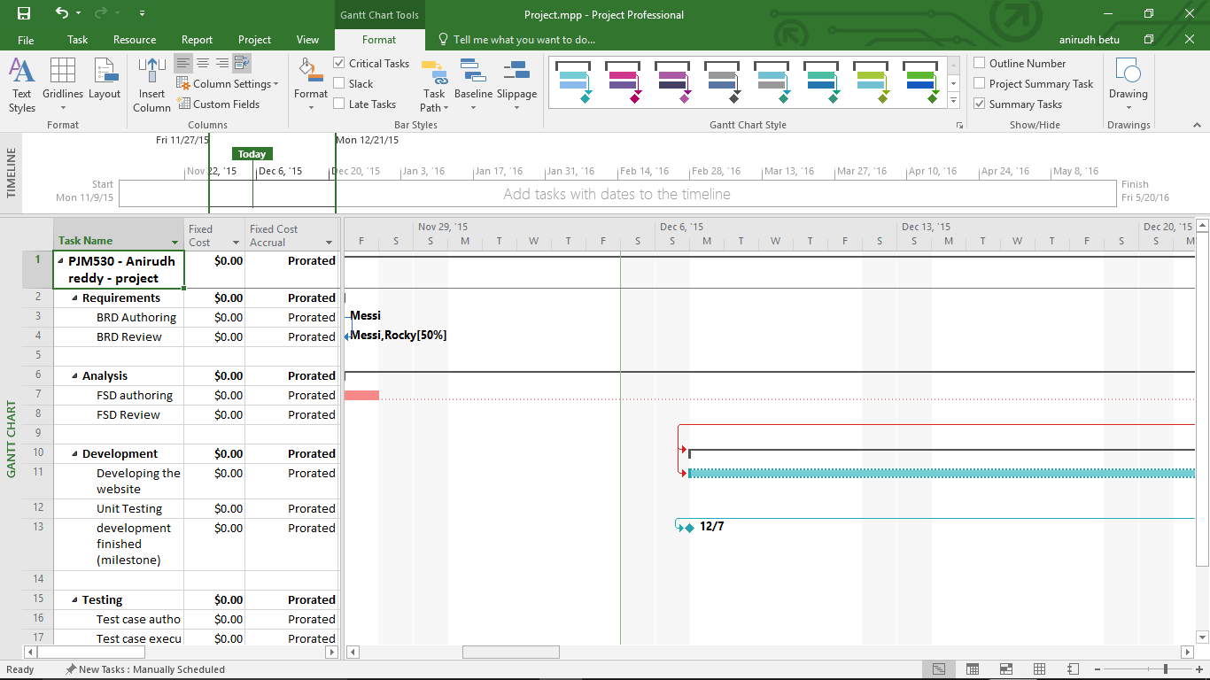

1. Reports

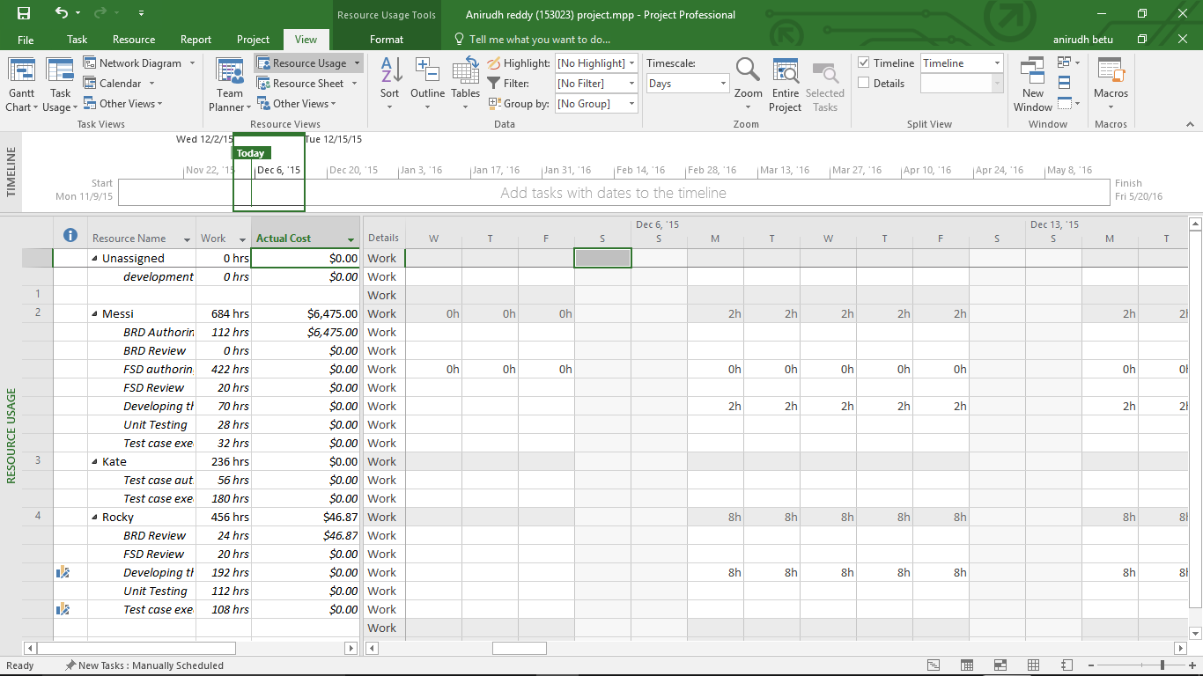

11) Time line to copy to presentation

For time line – right click on timeline -> copy time line -> for presentation.

Start  
Mon 11/9/15

Finish  
Fri 5/20/16

Nov 22, '15

Dec 6, '15

Dec 20, '15

Jan 3, '16

Jan 17, '16

Jan 31, '16

Feb 14, '16

Feb 28, '16

Mar 13, '16

Mar 27, '16

Apr 10, '16

Apr 24, '16

May 8, '16

**Today**

12) Calculate budget

BAC - stands for Budget at Completion

EAC - stands for Estimate at Completion

